**MINI PROJECT (20 MARKS)**

**Question**

Write html and CSS code to reproduce the following page:

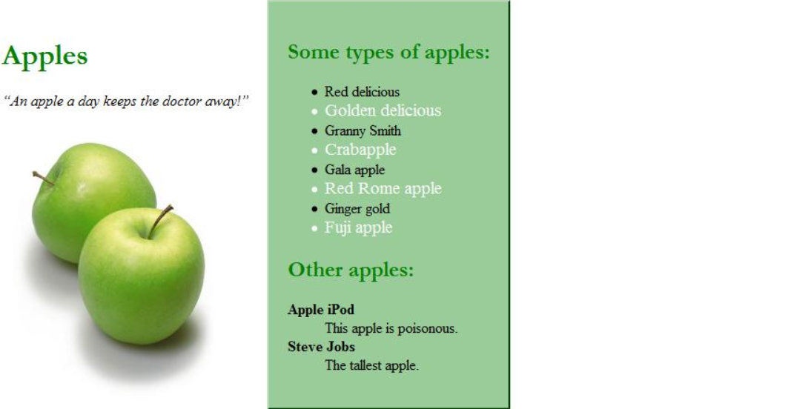

The following are the details about the appearance of the page:

* Make all headings green, and make them use Garamond font or any serif font on the system.
* The quote should be emphasized.
* The apples picture name is greenapple.jpg. It also links to <http://www.apple.com/>.
* All pictures should have no borders and be 250 pixels wide.
* The middle section has a 2-pixel wide outset green border and a background of #99cc99.
* Every other line in the "types of apples" list is white and its font-size is 120% as large as the other list items.
* The definition terms are bolded.
* Notice that there are three distinct sections on the page: (from left to right) main, about and details.
* The details section shows an image and a description when a type of apple in the list is clicked.
* The content inside each section should be 20 pixels away from all edges.
* Note: Don't forget to use proper tags for all of the elements that clearly describe the content on the page.